**MINI PROJECT**

(2019-20)

**NOTESBOG**

**(Web Development)**

**REPORT**

**Department of Computer Engineering and Applications**

**Institute of Engineering and Technology**



**GLA University Mathura- 281406, INDIA 2019**

**Submitted to: Submitted by:**

Mr. Sharad Gupta Vaishali Jain (Assistant Professor) (171500370)

Divyanshu Singh

(171500104)

**Declaration**

I hereby declare that the work which is being presented in the Mini Project “NotesBog”, in full-fillement of the requirements for Semester-6th viva voce, is an authentic record of my own work carried under the supervision of “G.L.A. University”.

**Signature of Candidate:** vaishali

divyanshu

**Name of Candidate:** Vaishali Jain

Divyanshu Singh

**Roll No.:**171500370

171500104

**Course:** B.tech

**Year:** 3rd

**Semester:** 6th



**Certificate**

This is to certify that **Vaishali Jain**  and **Divyanshu Singh** Third Year Computer Science Engineering have completed the project entitled “**NotesBog on Web Development**” for the organisation “**GLA University**”.

**Abstract**

The report presents the three tasks that is being in continuation during college time at GLA University which are listed below:

1. Understanding of the Problem objective & business implication.

2. Understanding of the data & building of the Web Design.

3. Development of the Website.

All these tasks have been completed successfully and results were according to expectations. All the tasks were need very systematic approach, starting from the collection of the data to the implementation of the solution and till evaluation of the Website.

**In the last semester, we have designed the frontend part of this project, In this semester, we have completed the website with backend using php, mysql.**

**Acknowledgment**

It gives us a great sense of pleasure to present the report of the B.tech Mini Project (NOTESBOG) undertaken during B.tech IIIrd Year. This project in itself is going to be an acknowledgement to the inspiration, drive and technical assistance will be contributed to it by many individuals.

We owe special debt of gratitude to Mr. Sharad Gupta, Assistant Professor Department of CEA, for providing us with an encouraging platform to develop this project, which thus helped us in shaping our abilities towards a constructive goal and for his constant support and guidance to our work. His sincerity, thoroughness and perseverance is been a constant source of inspiration for us. We believe that he will shower us with all his extensively experienced ideas and insightful comments at different stages of the project & also taught us about the latest industry-oriented technologies.

We also do not like to miss the opportunity to acknowledge the contribution of all faculty members of the department for their kind guidance and co-operation.

**Vaishali Jain**

(171500370)

**Divyanshu Singh**

()

**Contents**

**Declaration…………………………………………………….. (2)**

**Certificate……………………………………………………… (3)**

**Abstract………………………………………………………... (4)**

**Acknowledgement…………………………………………….. (5)**

**1. Introduction………………………………………………… (7)**

1.2 Motivation………………………………………………. (7)

1.3 Objective………………………………………………... (7)

**2. Software Requirement Analysis…………………………... (7)**

2.1 Problem Definition …………………………………….... (7)

2.2 Functional Requirements…...…………………………... (8)

**3. Software Design……………………………………………. (12)**

3.1 Use Case Diagram (12)

3.2 ER Diagram (12)

3.3 Class Diagram (13)

3.4 Data Flow Diagram (13)

**4. Testing……………………………………………………… (13)**

4.1 Webpage Conceptualization……………………………. (13)

4.2 Evaluation and fine-tuning……………………………... (14)

4.3 Data Migration Phase…………………………………… (14)

4.4 Pre Deployment Phase………………………………….. (14)

4.5 Website Handover……………………………………… (14)

**5. Implementation Details…………………………………… (14)**

**6. Summary…………………………………………………... (15)**

**7. User Interface……………………………………………… (15)**

**8. Requirements………………………………………………. (27)**

**References & Bibliography………………………………….. (28)**

**Appendices……………………………………………………. (29)**

**1. Introduction**

**1.1 Motivation:**

Many people say that today’s college students have it easy. All information they need is at their fingertips, so they can easily complete all academic projects after browsing the Internet for a few hours. However, that’s not what happens in reality. The curriculum has become more rigorous than ever, so college students have to think of different ways on increasing their productivity and motivation.

So for that website is being created that will improve their skills of time management, planning, brainstorming, writing, etc.

**1.2 Objective:**

The objective of this project is to build a backend of the website which is education based. In this, students can learn online any language, course, etc. It would be free and open source. This website will easily be available on the internet so students can access it easily.

**2. Software Requirement Analysis**

**2.1 Problem Definition:**

How to overcome a problem of learning. How we can create an easy, open source, online free learning platform which can help students to learn easily and efficiently online & main focus is on  **building the backend of the website.**

In this project, I am creating a website based on learning material and it will be a web developer site, with tutorials and references on web development language such as HTML, CSS, JavaScript, PHP, SQL, Python, jQuery, Java, Bootstrap, covering most aspects of web programming.

* The site drives its name from the Notesbog.
* Notesbog has focus on simplicity.
* Notesbog use simple code explanations with simple illustrations of how to use it.
* Notesbog tutorials start from basic level and move all the way up to professional references.

As we faced many problems while studying due to non-availability of good content on the particular topic. So, it will be a source to all those problems. Students can learn about a particular topic in this and after studying that topic can solve a practice exercise that will be provided to them at the end of particular topic.

Many sample papers, important point regarding projects based on a particular topic, short tricks to learn will also be provided in this website.

It will be too simple and students friendly.

They will enjoy and enhance their interest while studying from this website.

**2.2 Functional Requirements:**

* **HTML:**

**Hypertext Markup Language (HTML)** is the standard markup language for documents designed to be displayed in a web browser. It can be assisted by technologies such as Cascading Style Sheets (CSS) and scripting languages such as JavaScript. Web browsers receive HTML documents from a web server or from local storage and render the documents into multimedia web pages. HTML describes the structure of a web page semantically and originally included cues for the appearance of the document.



* **CSS:**

**Cascading Style Sheets (CSS)** is a style sheet language used for describing the presentation of a document written in a markup language like HTML.[1] CSS is a cornerstone technology of the World Wide Web, alongside HTML and JavaScript.[2] CSS is designed to enable the separation of presentation and content, including layout, colors, and fonts.[3] This separation can improve content accessibility, provide more flexibility and control in the specification of presentation characteristics, enable multiple web pages to share formatting by specifying the relevant CSS in a separate .css file, and reduce complexity and repetition in the structural content.



* **JavaScript:**

JavaScript is a dynamic computer programming language. It is lightweight and most commonly used as a part of web pages, whose implementations allow client-side script to interact with the user and make dynamic pages. It is an interpreted programming language with object-oriented capabilities.



* **jQuery:**

jQuery is a JavaScript library designed to simplify HTML DOM tree traversal and manipulation, as well as event handling, CSS animation, and Ajax. ... jQuery's syntax is designed to make it easier to navigate a document, select DOM elements, create animations, handle events, and develop Ajax applications.



* **Bootstrap:**

Bootstrap is a free and open source front end development framework for the creation of websites and web apps. The Bootstrap framework is built on HTML, CSS, and JavaScript (JS) to facilitate the development of responsive, mobile-first sites and apps. ... The software is available precompiled or as source code.



* **Php:**

PHP started out as a small open source project that evolved as more and more people found out how useful it was. Rasmus Lerdorf unleashed the first version of PHP way back in 1994.

-PHP is a recursive acronym for "PHP: Hypertext Preprocessor".

-PHP is a server side scripting language that is embedded in HTML. It is used to manage dynamic content, databases, session tracking, even build entire e-commerce sites.

-It is integrated with a number of popular databases, including MySQL, PostgreSQL, Oracle, Sybase, Informix, and Microsoft SQL Server.

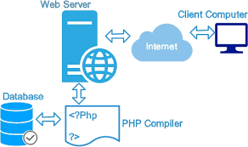

* **MySql:**

**DATABASE—**

A database is a separate application that stores a collection of data. Each database has one or more distinct APIs for creating, accessing, managing, searching and replicating the data it holds.

Other kinds of data stores can also be used, such as files on the file system or large hash tables in memory but data fetching and writing would not be so fast and easy with those type of systems.

Nowadays, we use relational database management systems (RDBMS) to store and manage huge volume of data. This is called relational database because all the data is stored into different tables and relations are established using primary keys or other keys known as **Foreign Keys**.

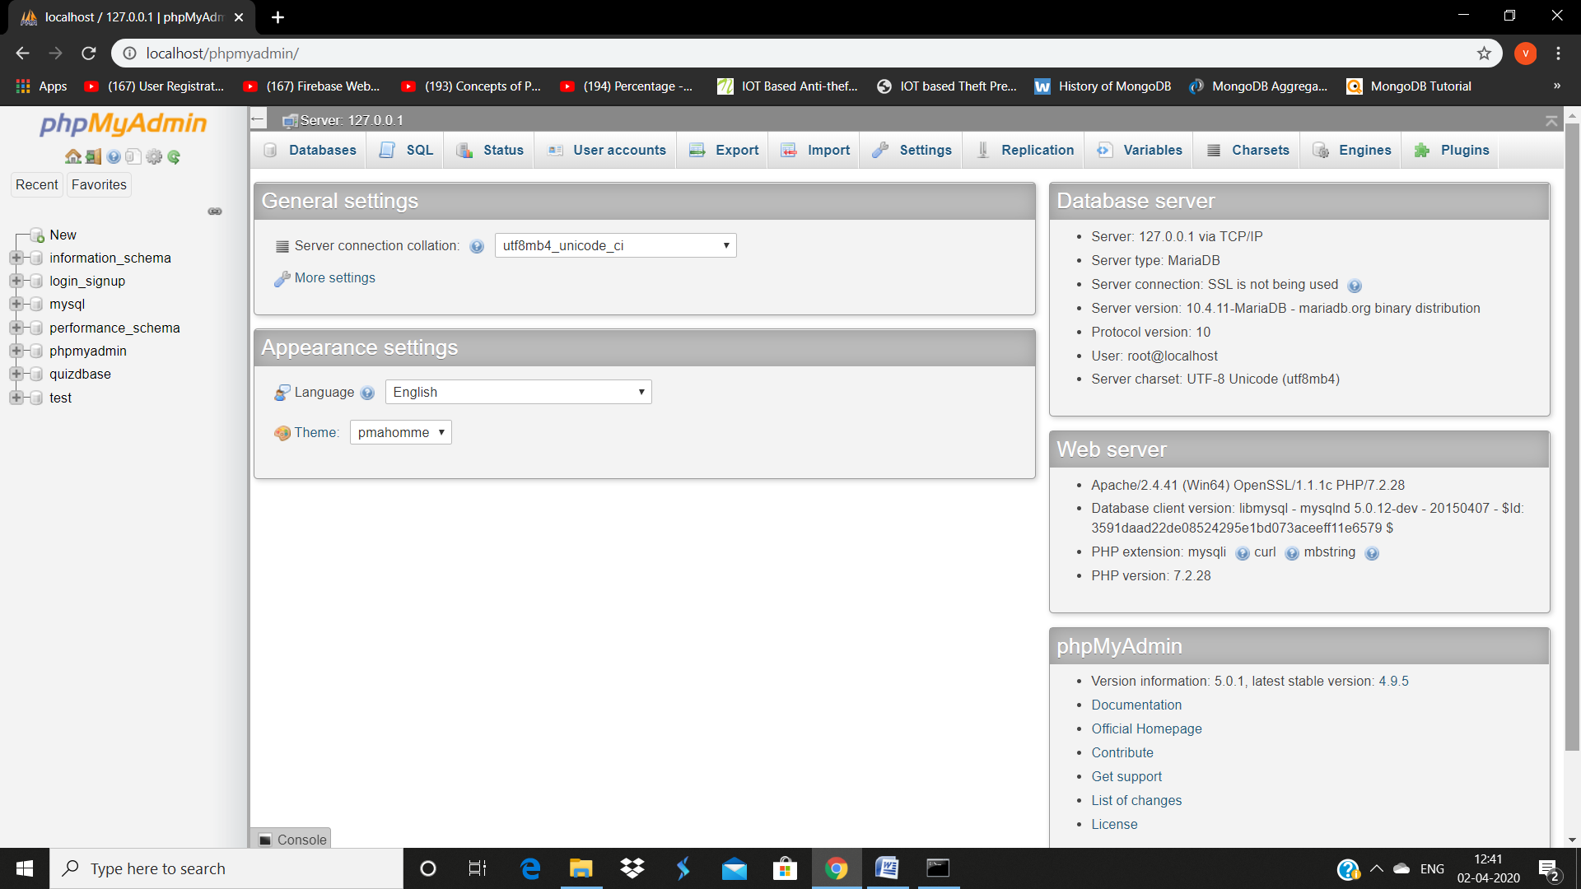

**3. Software Design**

* **User Case Diagram:** 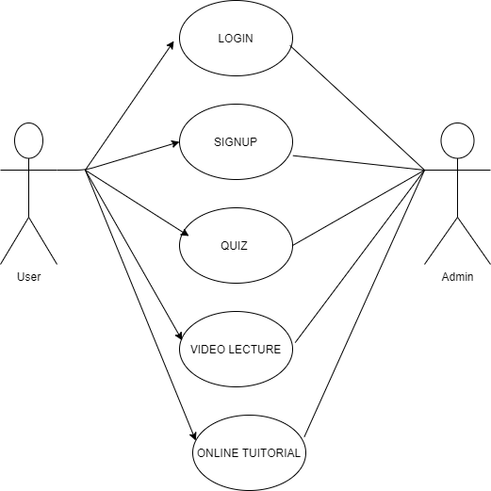
* **ER Diagram:**

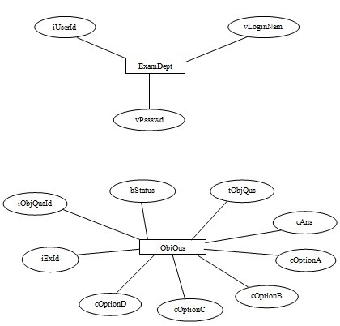

* **Class Diagram:**

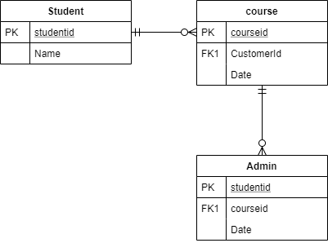

* **Data Flow Diagram:**

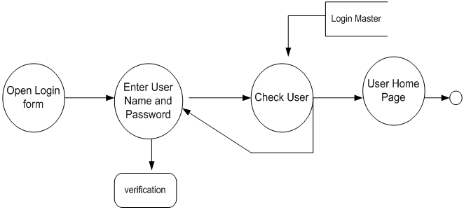

**4. Testing**

**4.1 Webpage conceptualization:**

We consider this stage to be one of the most crucial factors in any project. We justify every single aspect of the design to ensure that each element is serving a specific need and the website is truly designed to attract, retain and enhance the end user experience. We will be to develop three custom built, high-end website design templates or concepts, incorporating your marketing and communication strategy. Many thought processes and brainstorming will go into this process to create a design that is serving your existing needs as well as is sustainable with the future growth. Together with your input, we’ll come up with the designs that will effectively communicate your brand and online identity to your stake holders. The finalised concepts or templates will then be used for two other internal pages to give you an understanding of how internal content intensive pages will look. At this stage, we will submit designs and concepts for your review and feedback.

**4.2 Evaluation and fine-tuning:**

Once website is passed through the preliminary testing phase, we can handover the site for User Acceptance Testing to you if UAT is required. Upon receiving User Acceptance Testing signoff from you and based on your feedback, we will do the necessary changes to the website. Once all cleared from your end, we will proceed to the Data Migration phase.

**4.3 Data Migration phase:**

Once we have received the UAT signoff, we will proceed to migrate all data from your current website to your new website. You can alternatively provide new content in a word document (one document per page). Depending upon your project, migration is done manually, one page at a time. The content is also organised based on the new navigation panel and site structure. We also keep your primary and secondary keywords in mind while migrating the content over, so that you can take maximum advantage of the search engine indexes.

**4.4 Pre-deployment phase:**

Once the data has been ready, we submit the site for your review for final feedbacks. Once cleared, we will setup the site on the server where it is going to be deployed. Once setup on your server, website undergoes testing again to ensure that data integrity and quality of deliverables are maintained. The site will ready for the final deployment once pre-deployment phase is done.

**4.5 Website handover:**

Once the site is setup on your destination server, upon your approval we make the website live. One final set of testing is done on the live website for the quality assurance purposes. We then hand over the control of the site to you.

**5. Implementation Details**

* **Hardware Used:**

In this, i3 processor is used. Minimum 2GB RAM has been used in this project. The resolution is about 1024x765 has been used in this project. For database work, xampp has been used with php & mysql backend languages.

* **Software Used:**

The Operating System (**Window 10**) has been used. For coding purpose, (Sublime Text) software has been used. **Sublime Text** is cross-platform, available for macOS, Windows, and most Linux distributions. The main purpose of sublime text is its live HTML, CSS and JavaScript editing functionality. On November 4, 2014, Adobe announced the first (1.0) release of Brackets.

**6. Summary**

I have created a web developer website. In this website, I have used 5 languages that are HTML, CSS, JavaScript, Bootstrap, jQuery. This website has been made for education purpose. The website mainly made for those students who are interested in web designing, who wants to enhance their frontend making skills. This website consists of tutorials of all languages that are used in frontend designing like HTML Tutorial, CSS Tutorial, JavaScript Tutorial, Bootstrap Tutorial, jQuery Tutorial. The all tutorials are available in this website at free of cost. This website is an open source platform for beginners who are actually interested in web designing. The students can access it easily on Internet. There is login or register pages have beein made using php with mysql language with the help of xampp software of this website. The content provided in it is easy to understand and students friendly.

**7. UserInterface**

* **Home Page:**

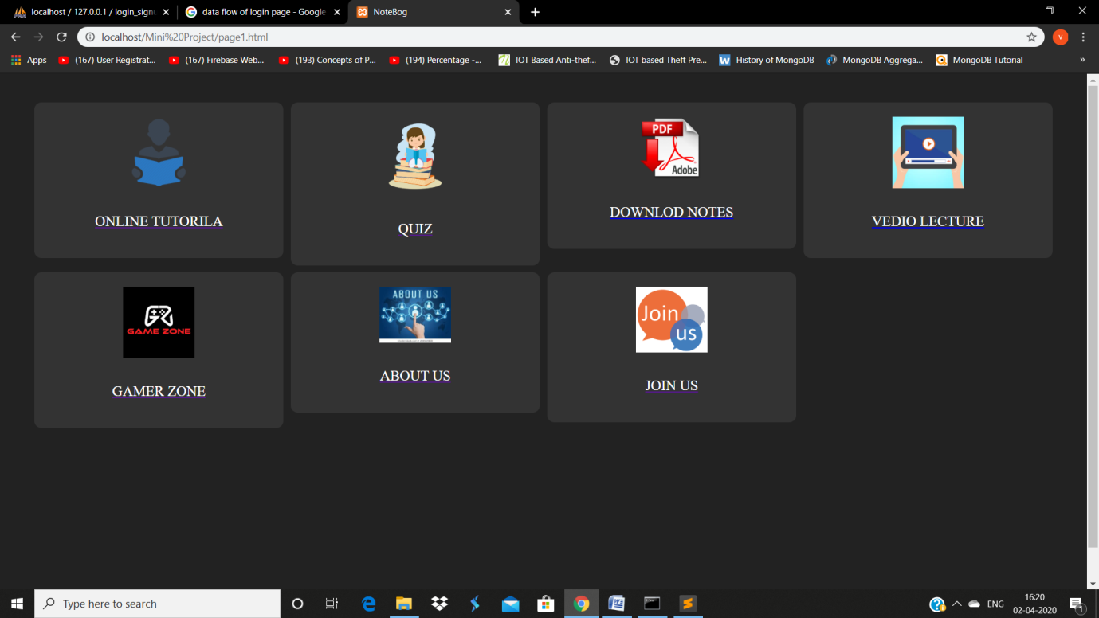

* **About:**

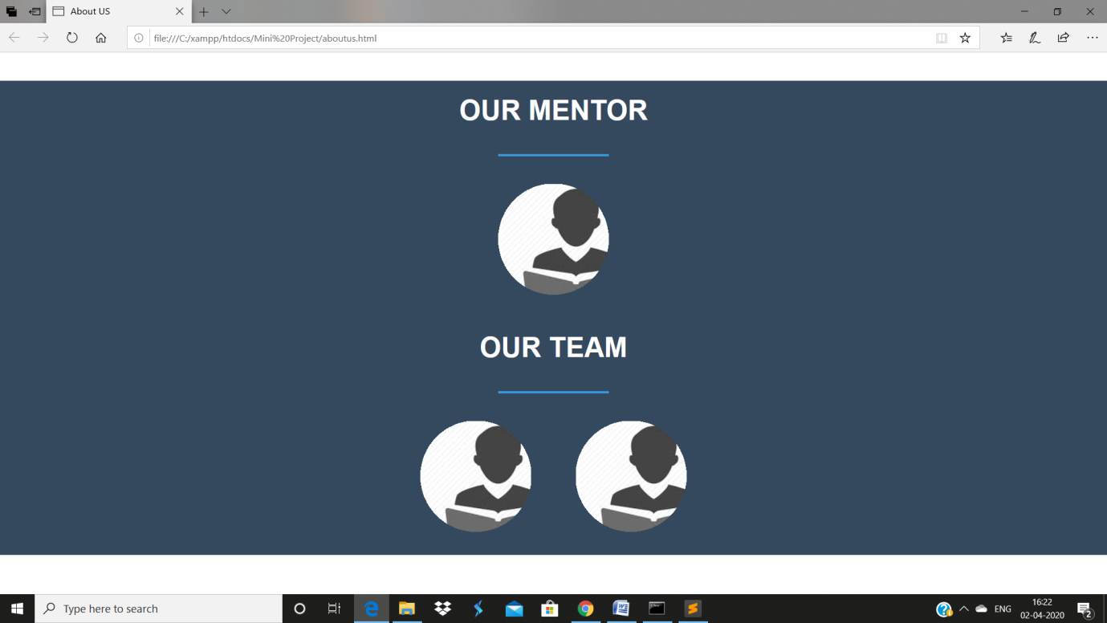

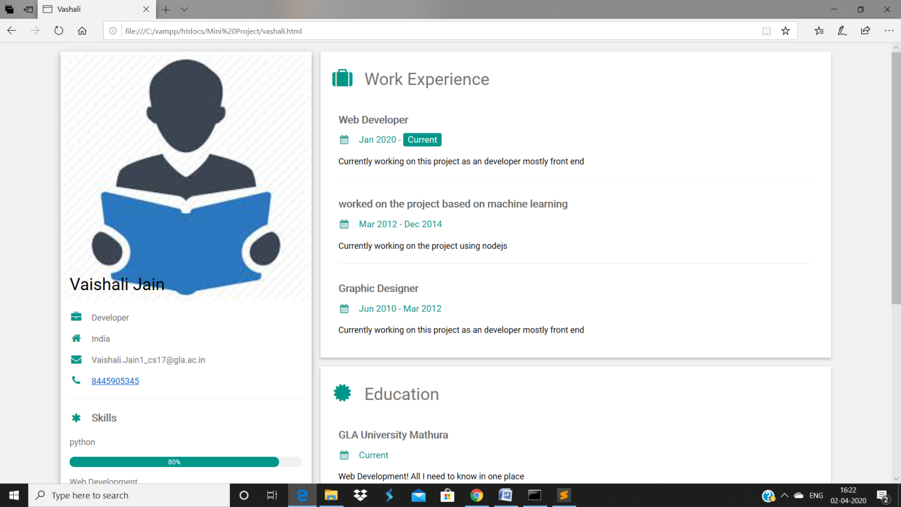

* **Online Tutorial**

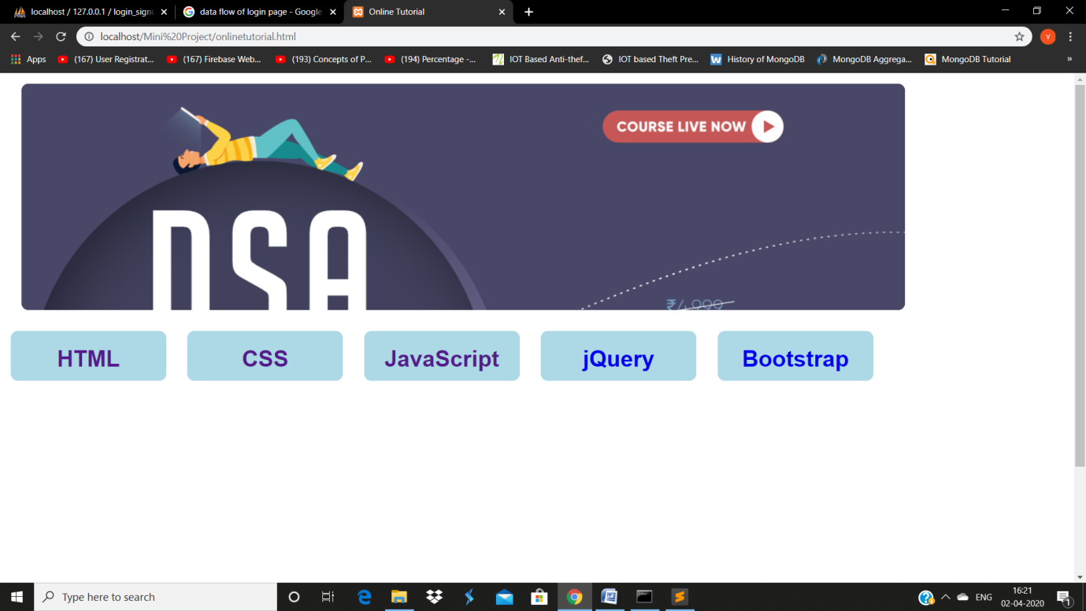

* **HTML**

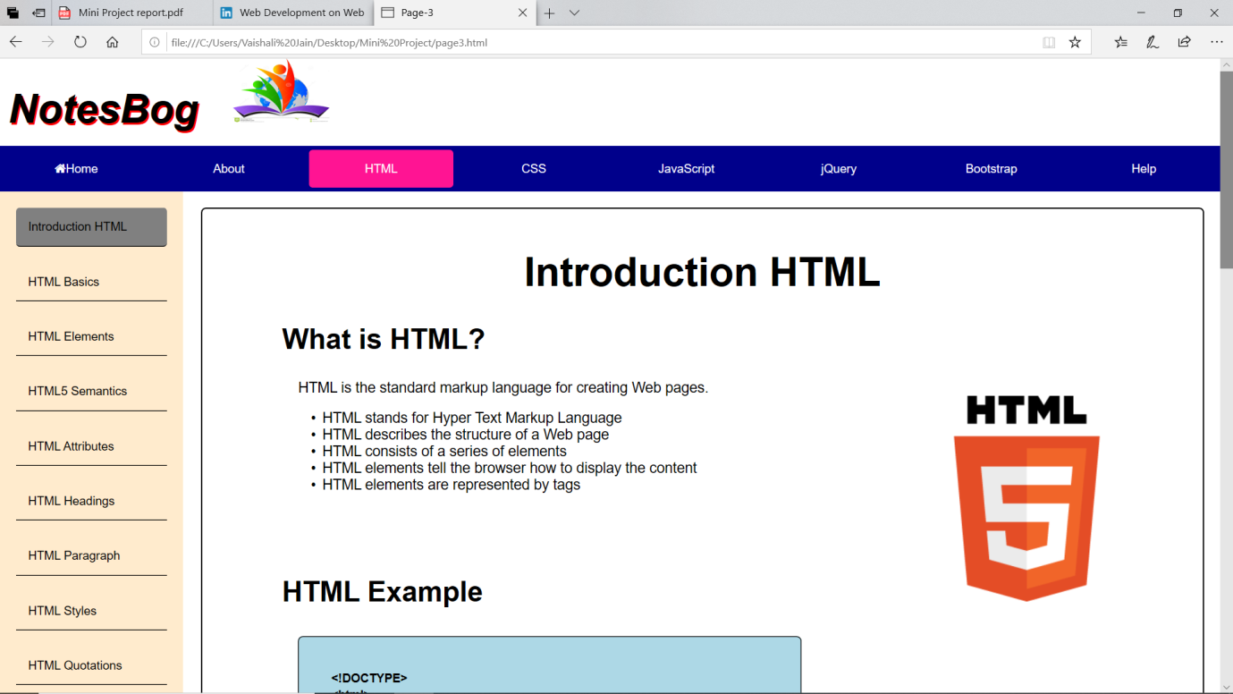

* **CSS**

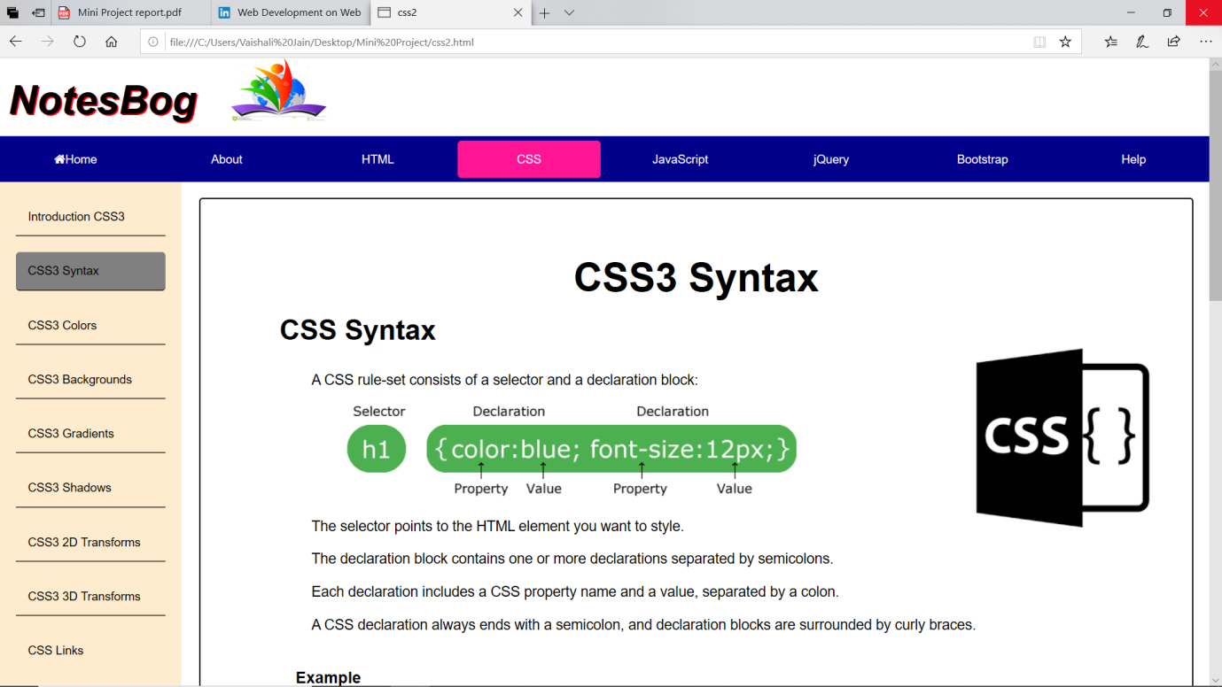

* **JavaScript**

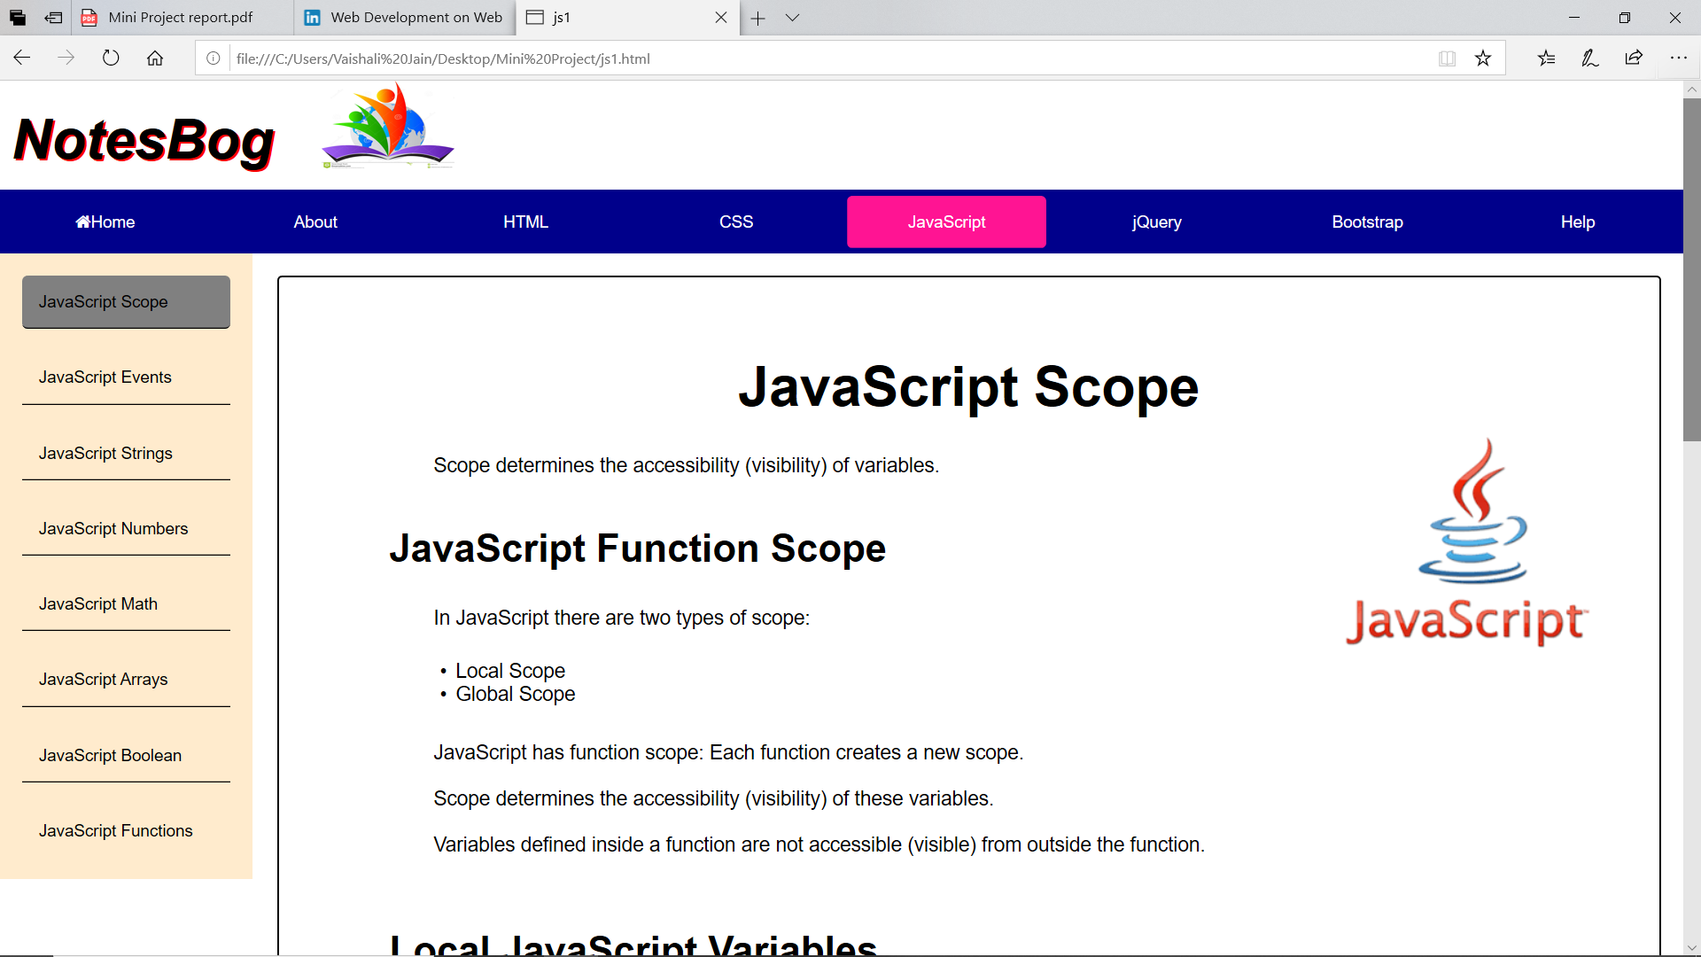

* **jQuery**

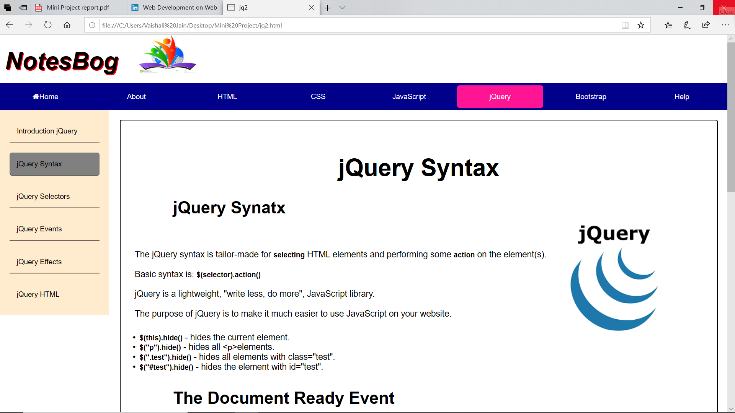

* **Bootstrap**

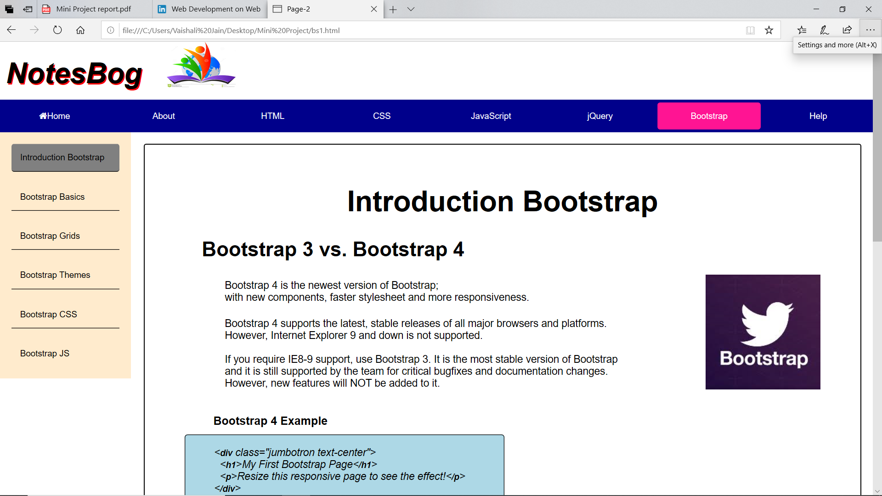

* **Online Quiz**

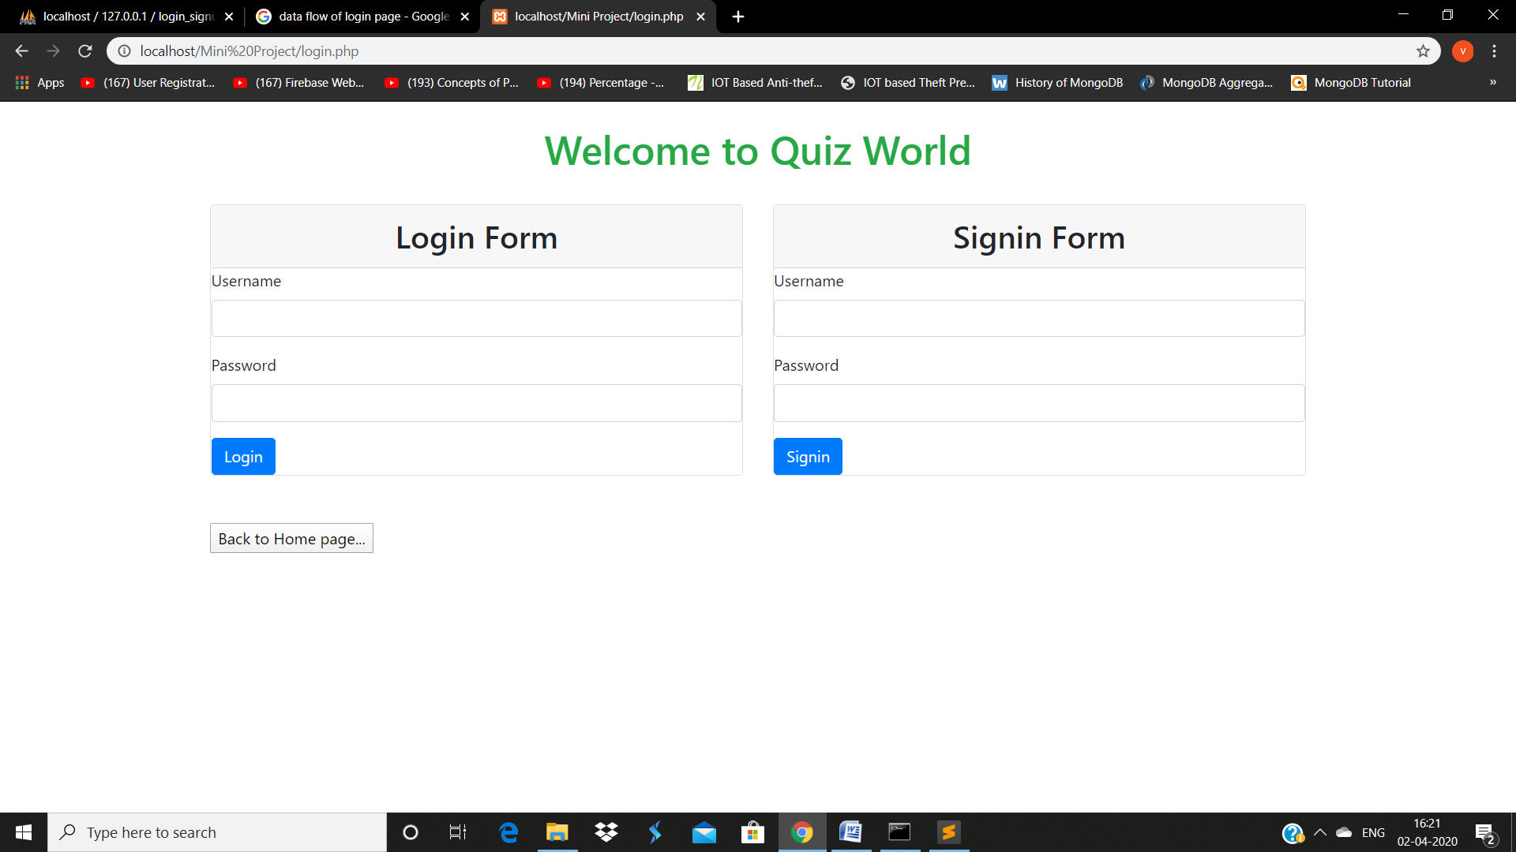

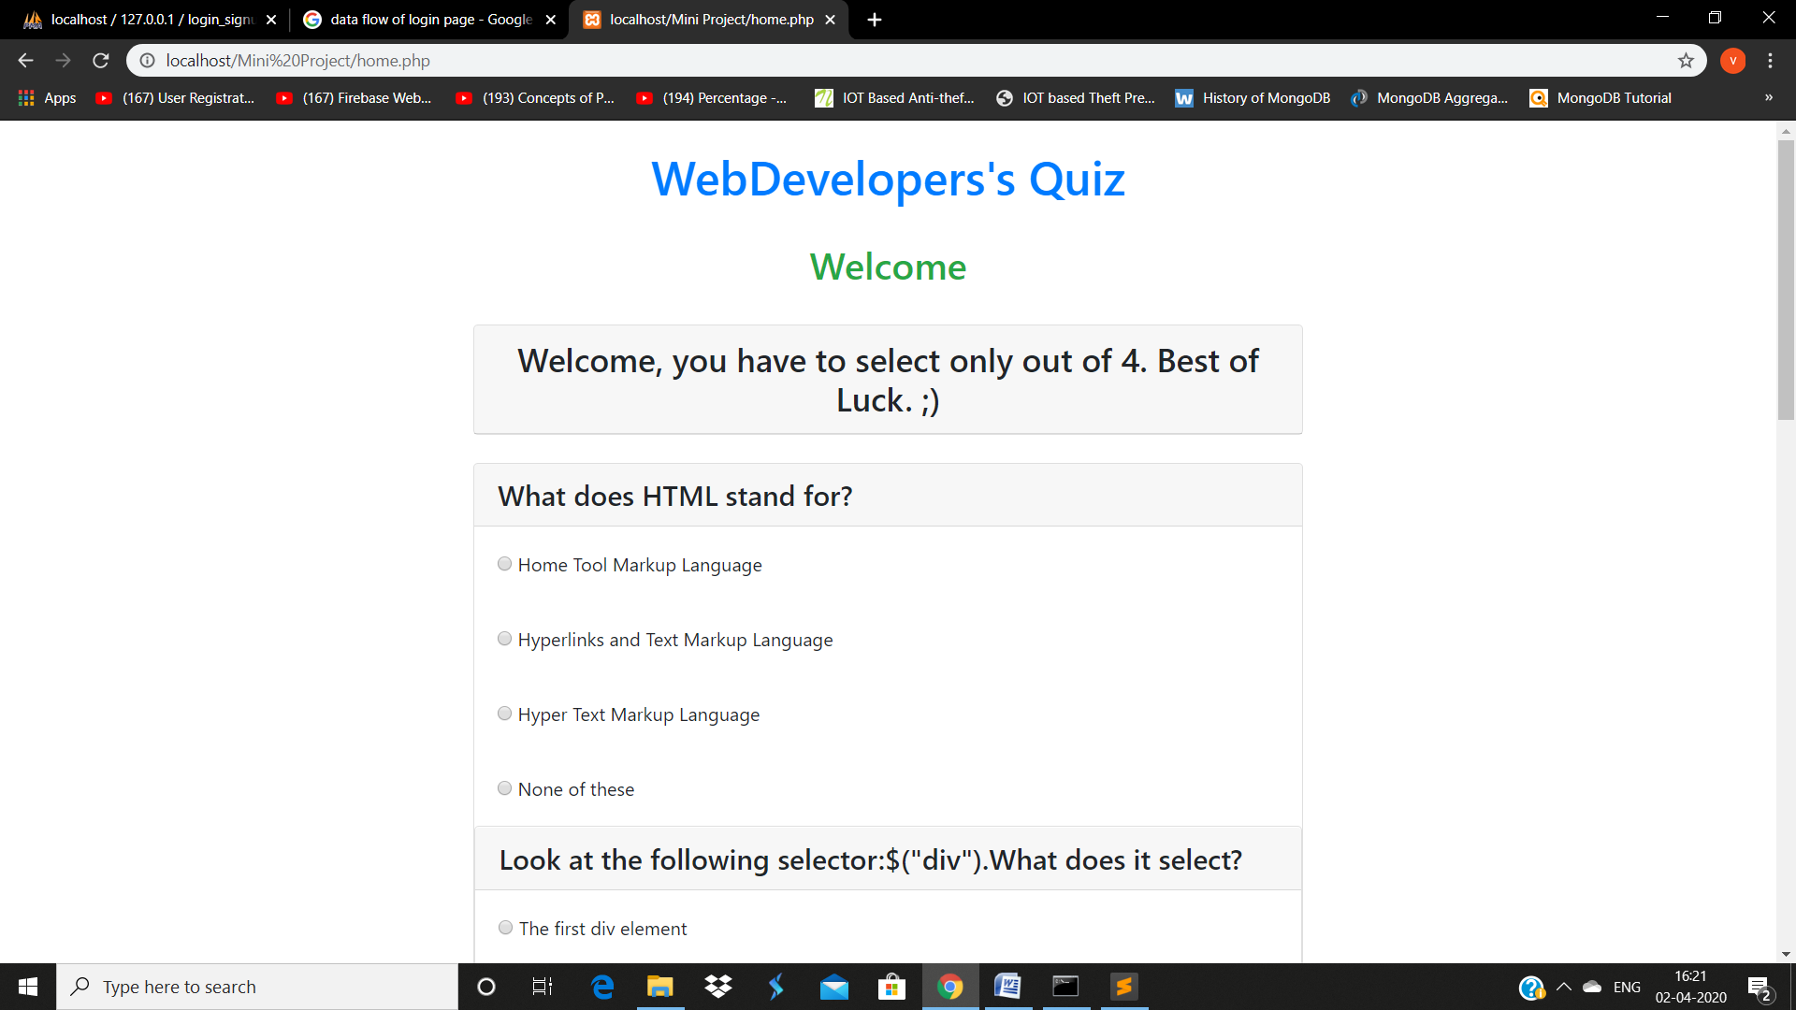

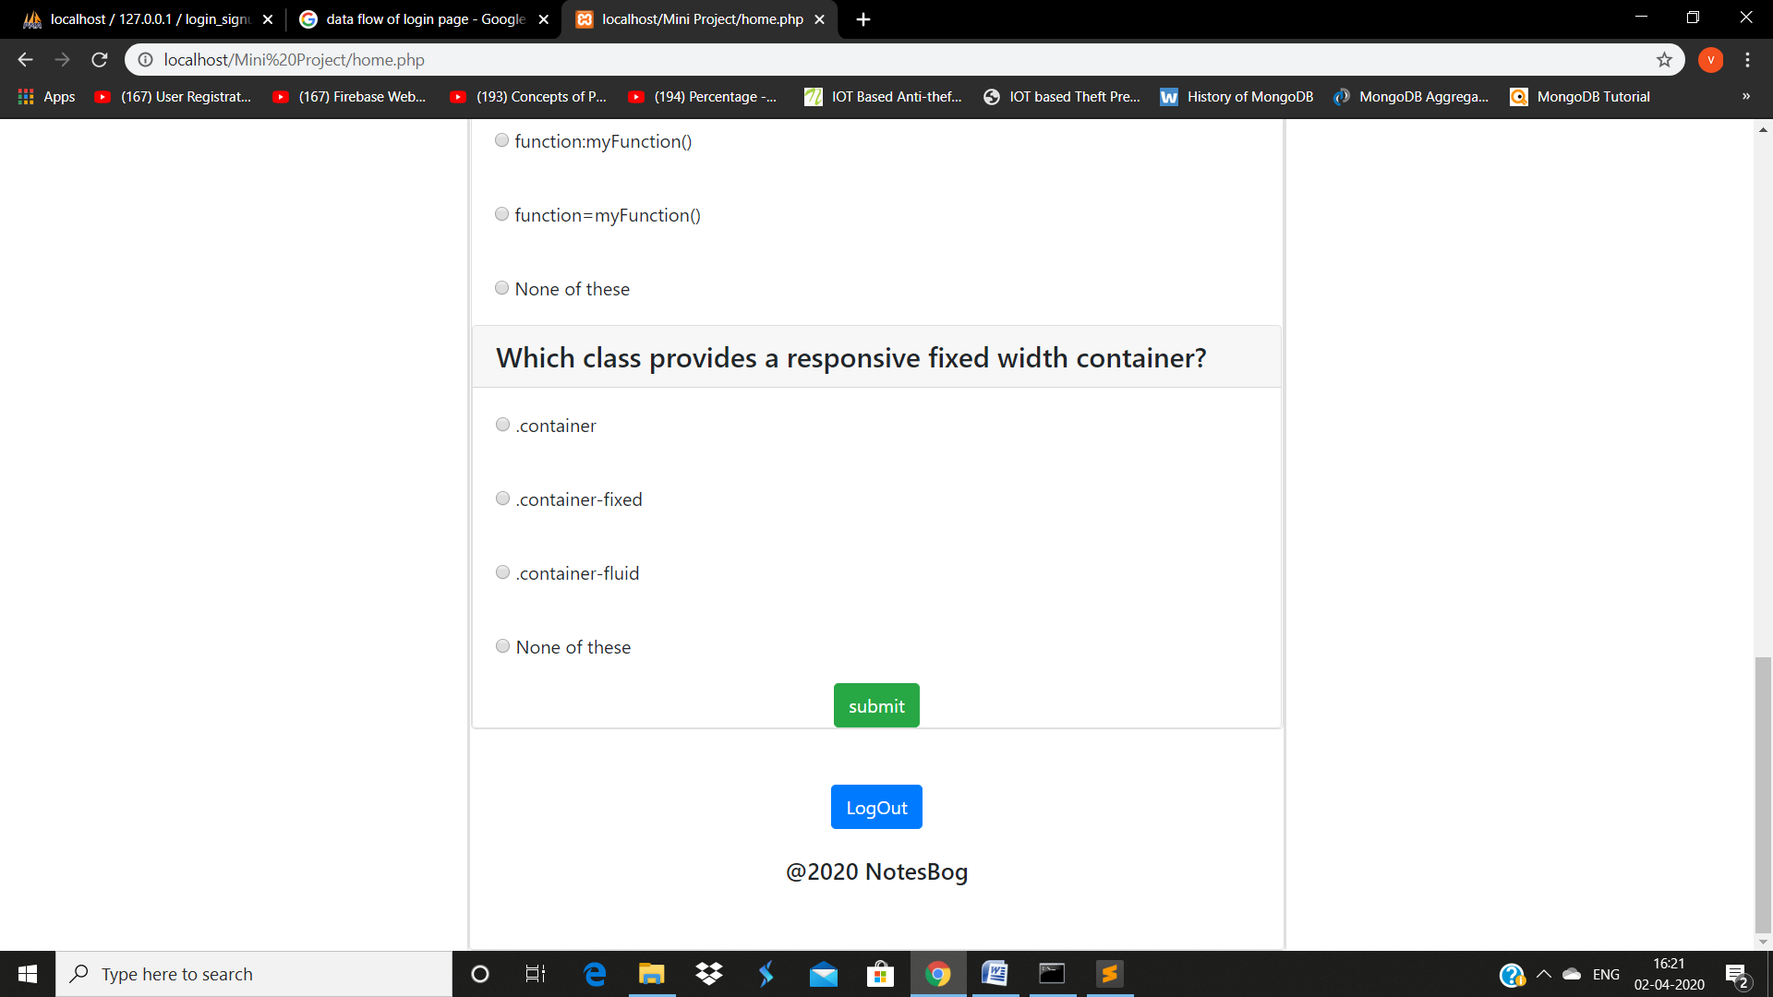

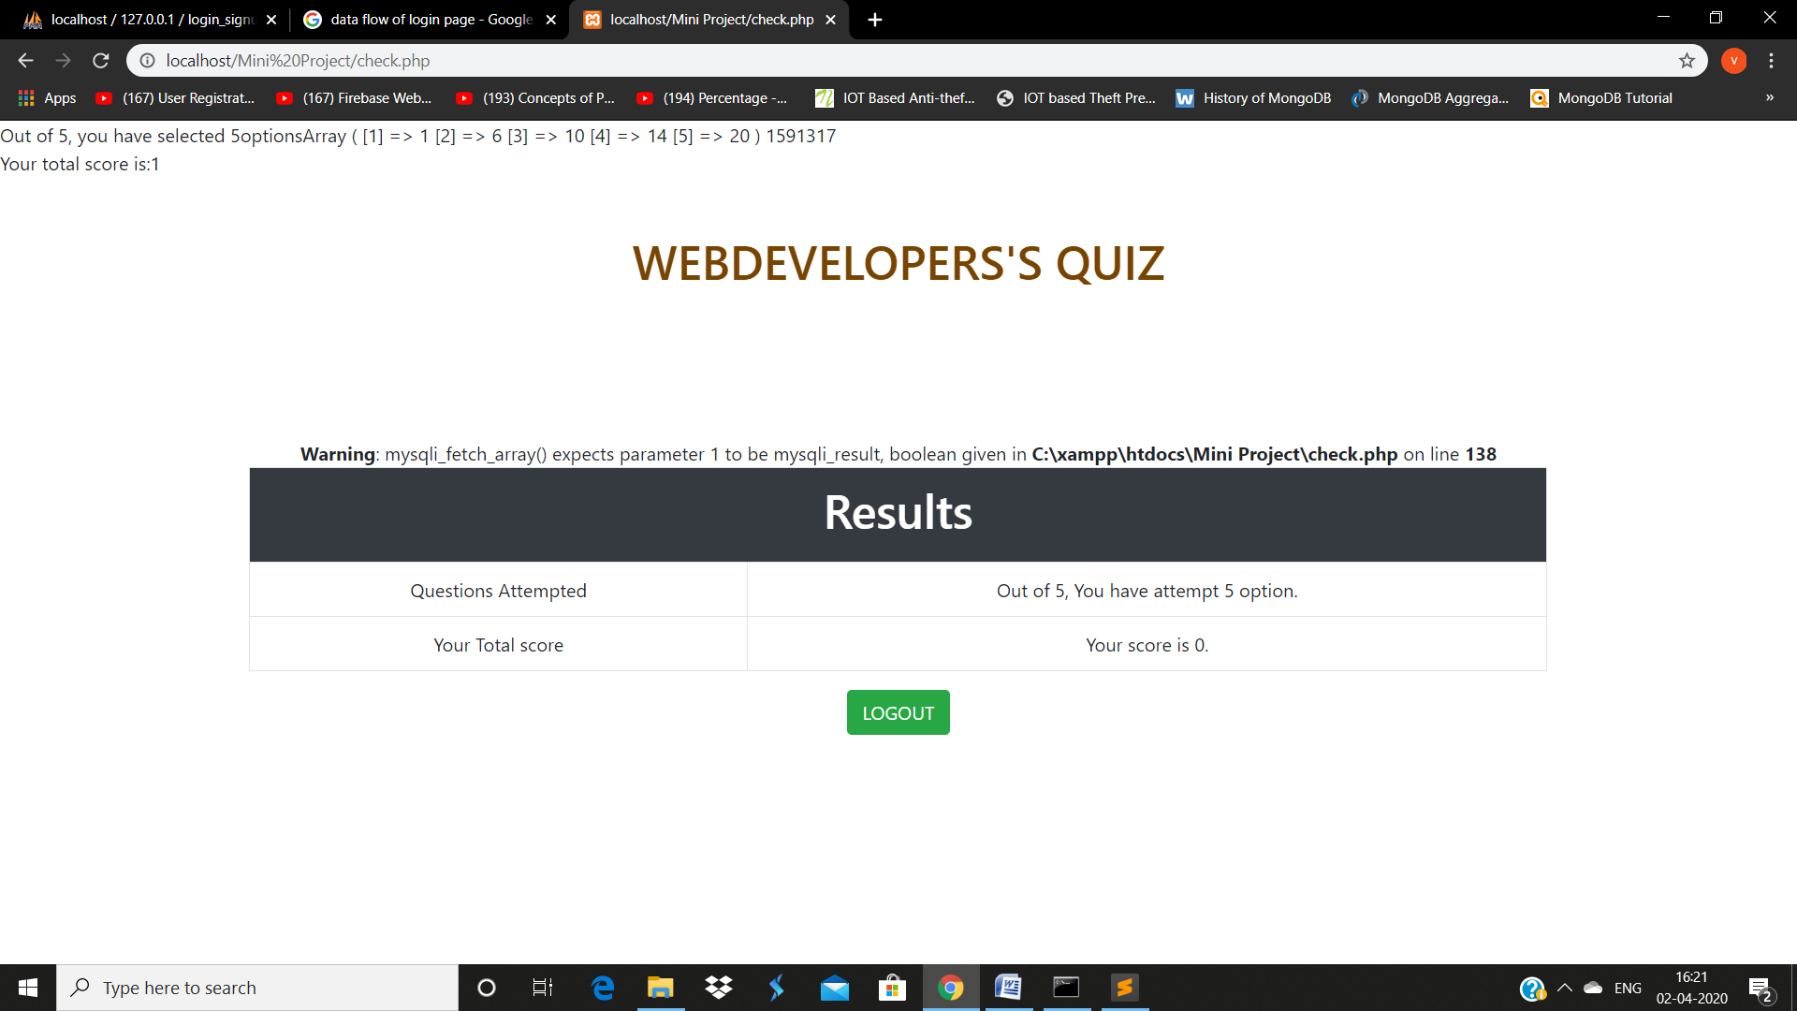

* **Contact Us**

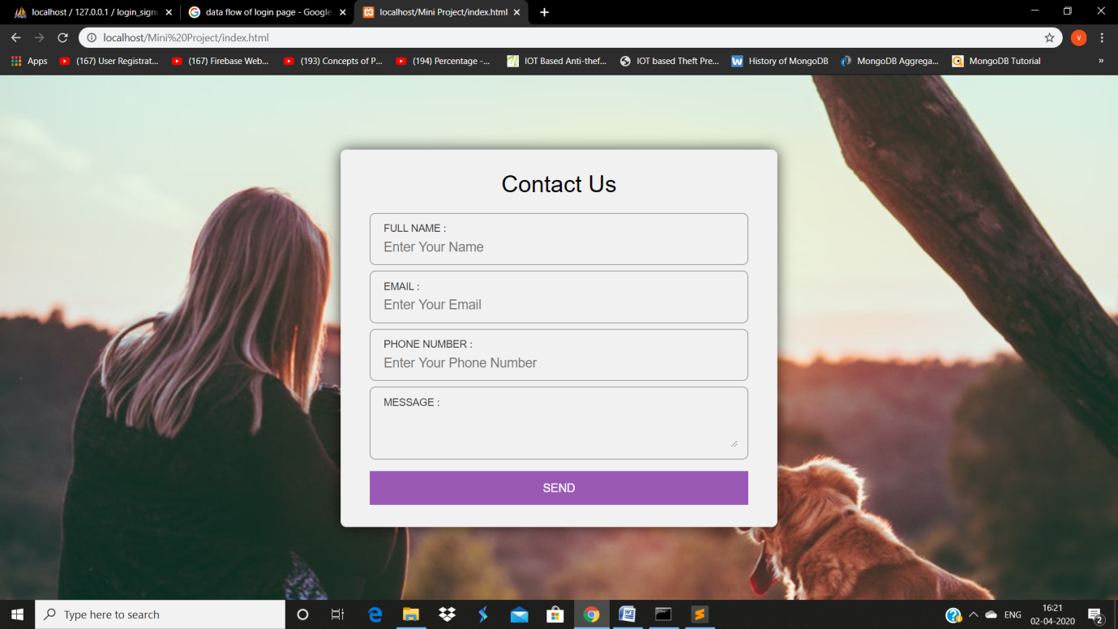

* **Gamer Zone**

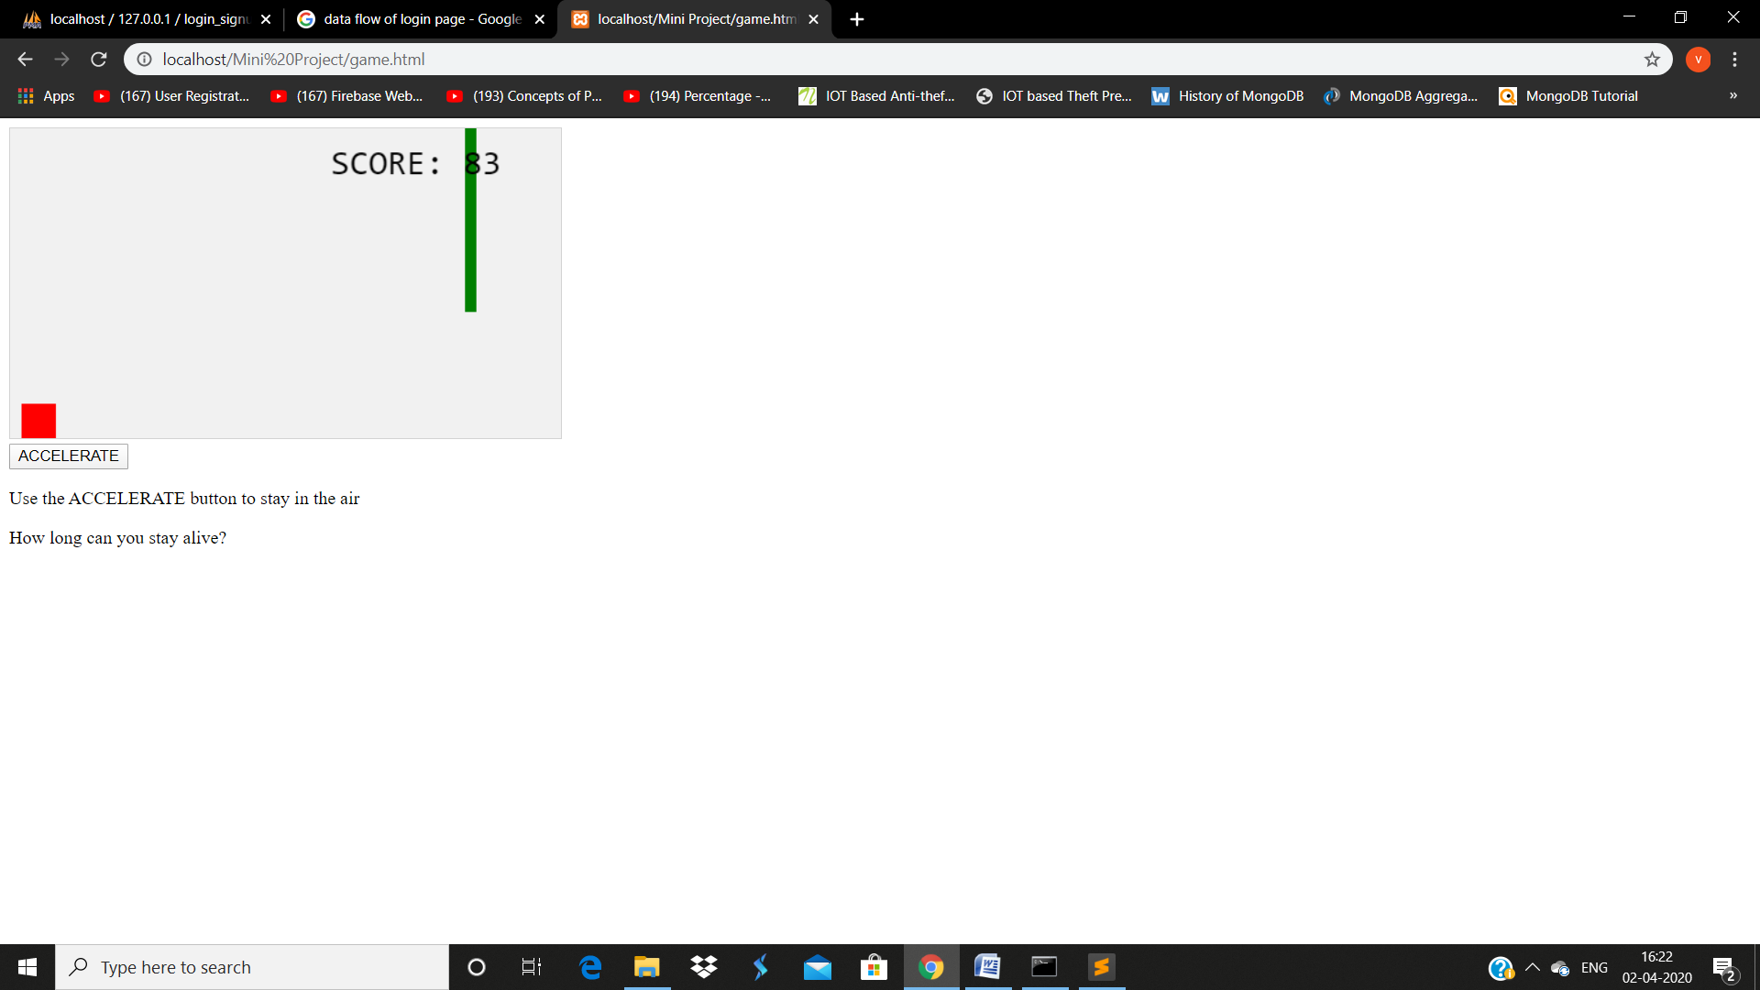

* **Databsese:**

**1. login & signup—**

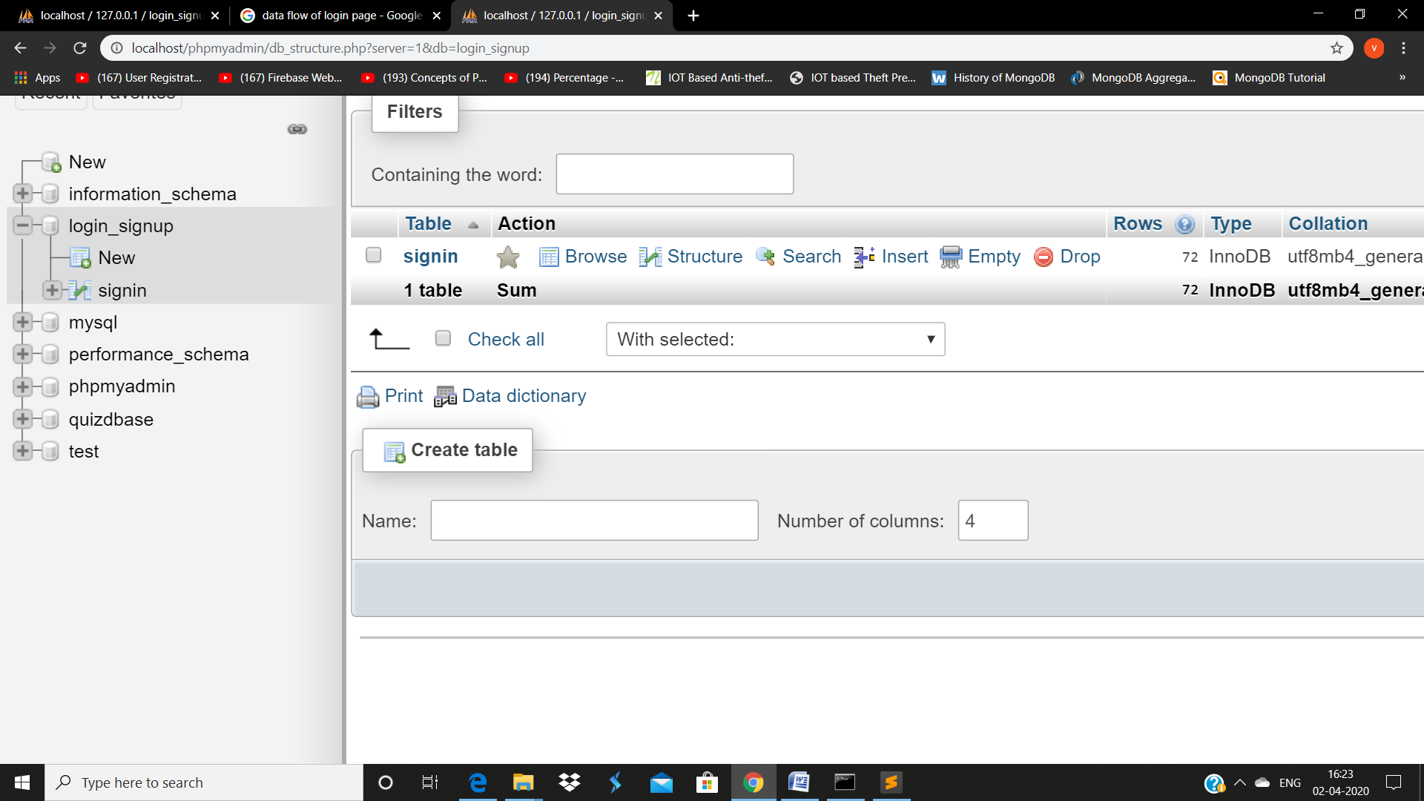

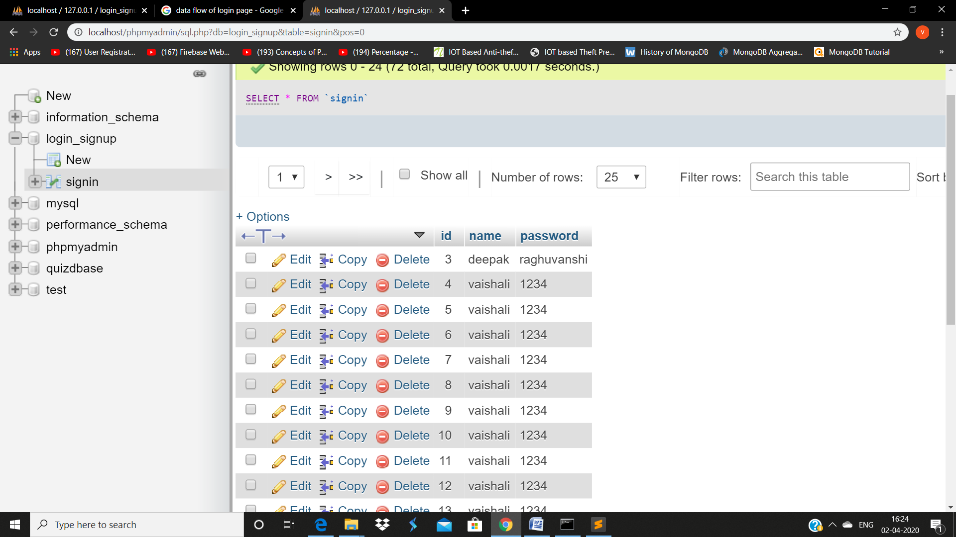

**2. Online Quiz---**

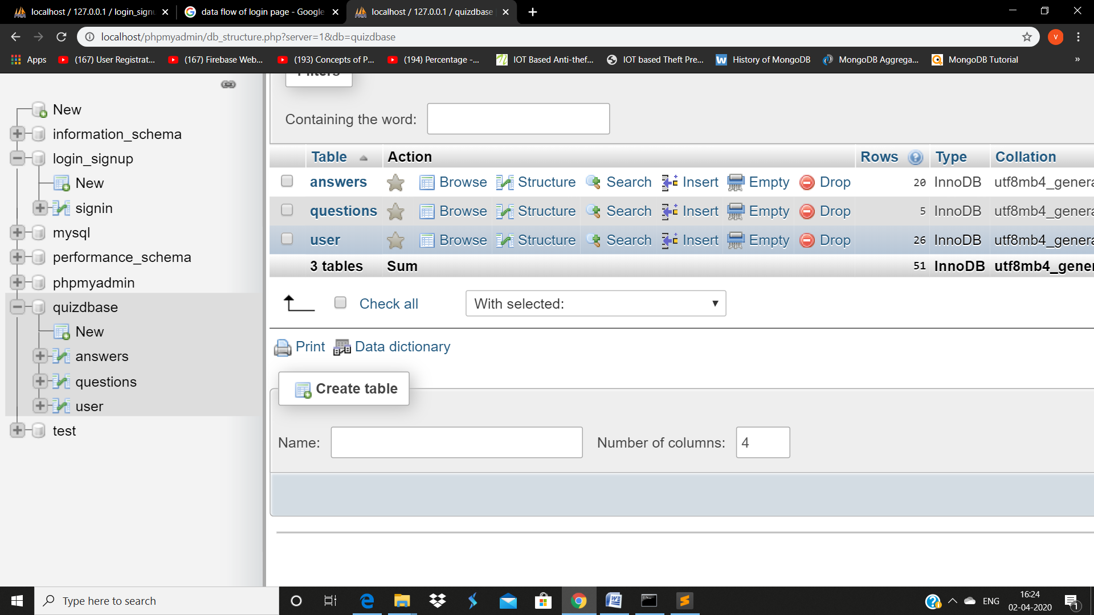

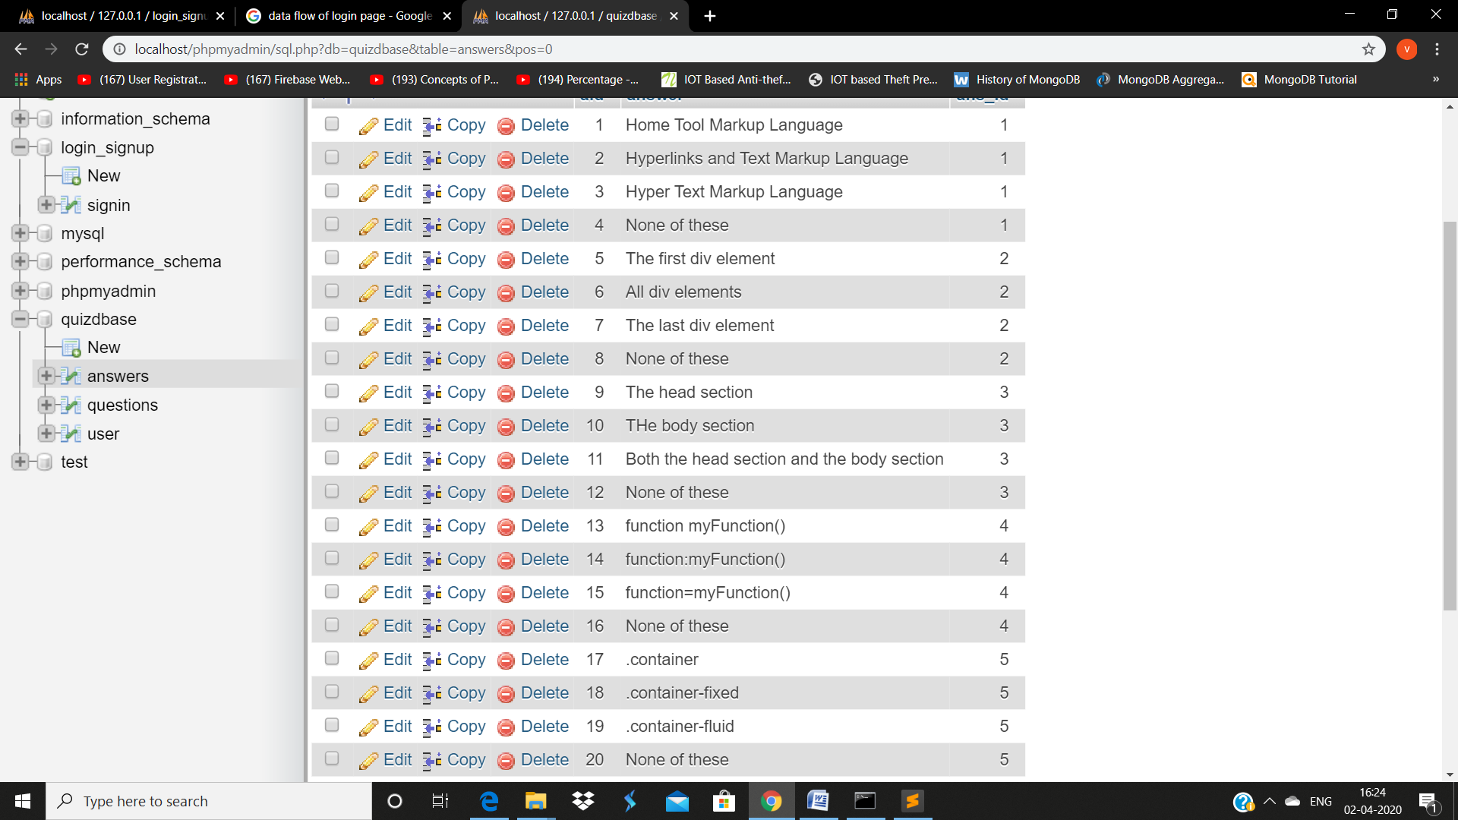

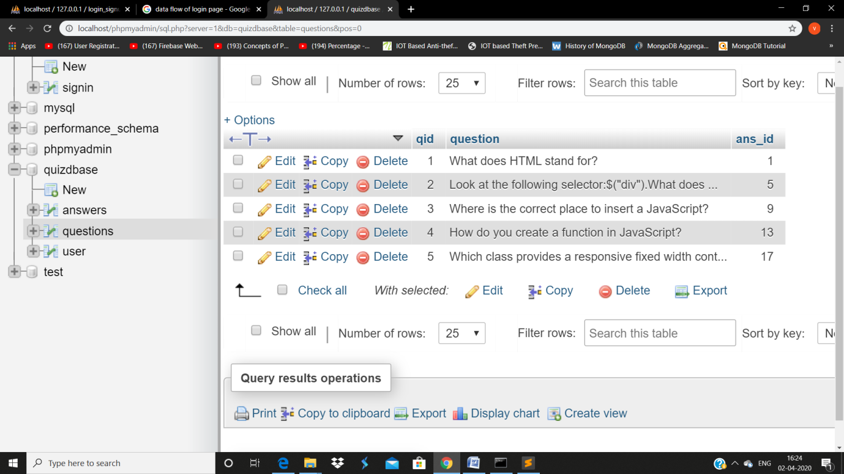

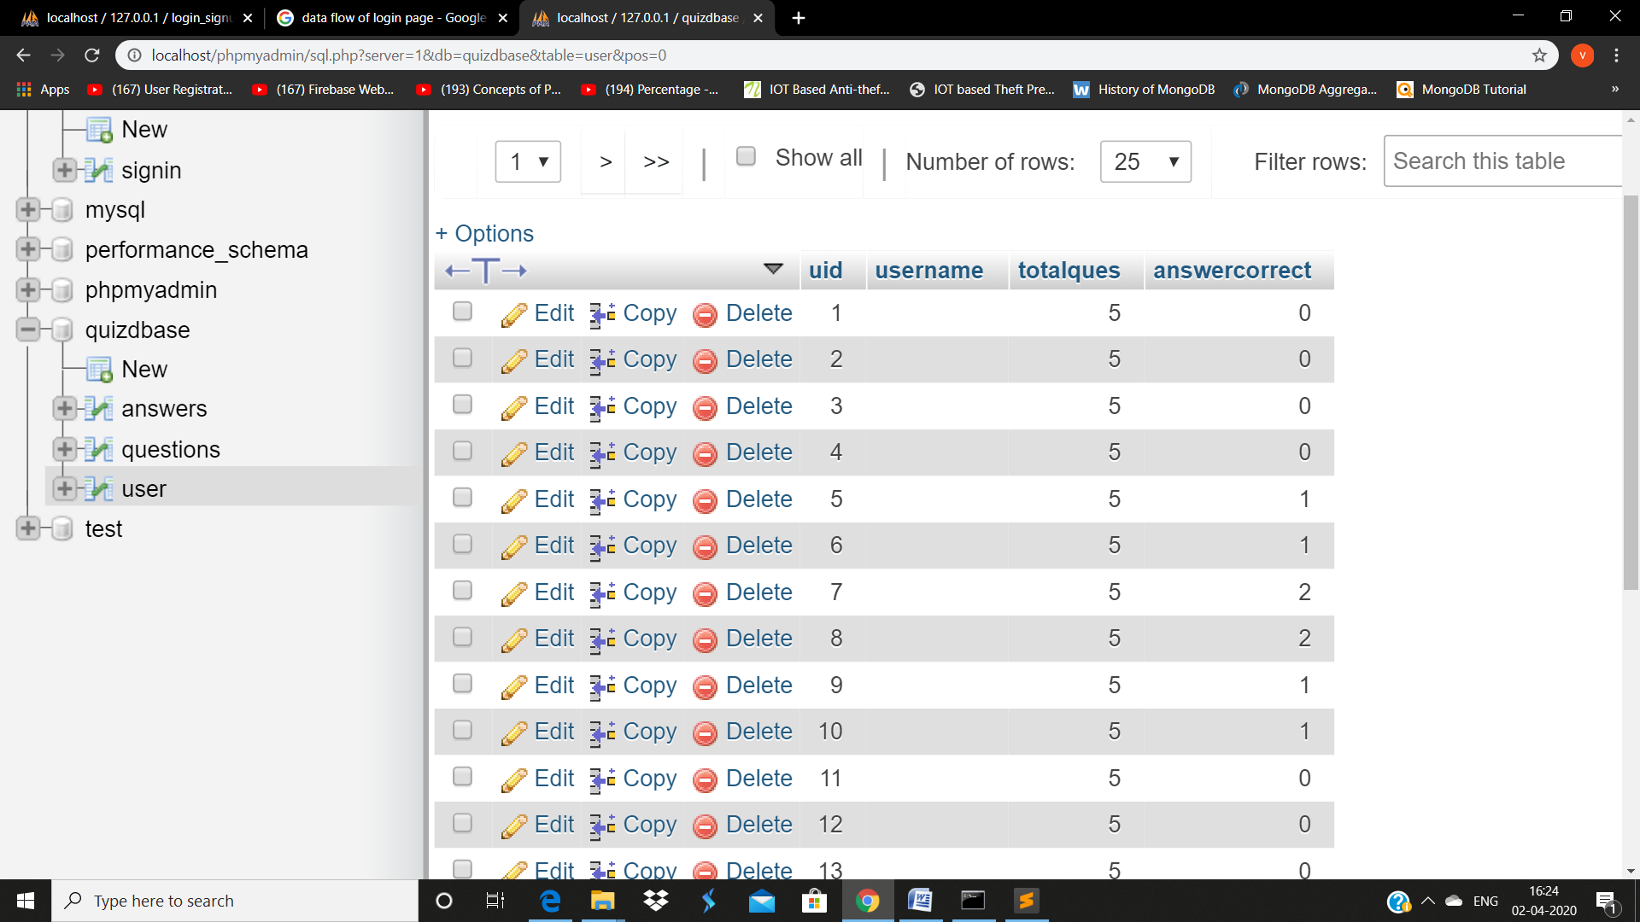

* **MySql work**

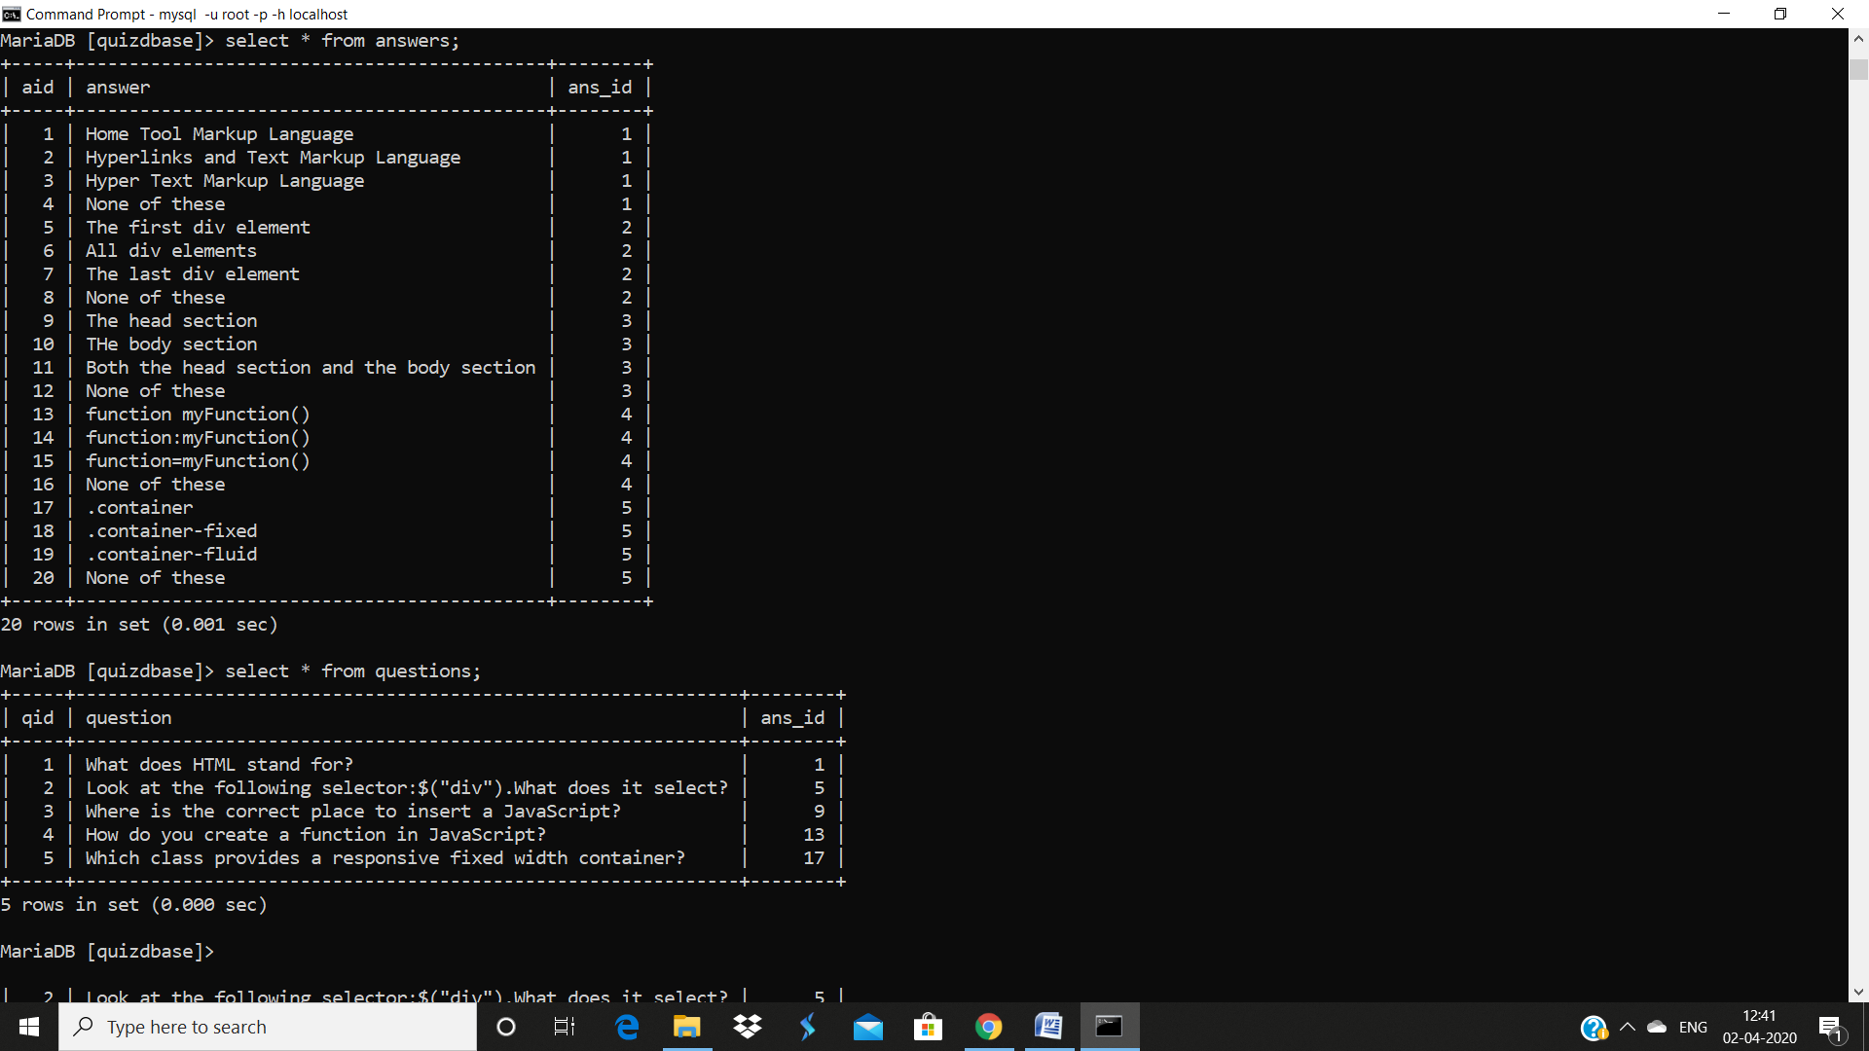

**8. Requirements**

**a) Hardware:**

* External Hard Drives or DVDs for Backup
* Minimum 2GB RAM
* i3 Processor
* 1024x765 Display

**-Server**

* Apache Tomcat Server

**b) Software:**

* Sublime Text
* Operating System (Window, Linux)
* **Programming Language**

-PHP

* **Front End**

**-**HTML, CSS, JavaScript, BootStrap, jQuery

* **Back End**

**-**DBMS

-My SQL/Oracle

**References & Bibliography**

* **Book References**
* Web Engineering Book
* Core Java Book
* [WWW.w3school.com](http://WWW.w3school.com)
* [WWW.javatpoint.com](http://WWW.javatpoint.com)
* WWW.youtube.com
* **Faculty Guidelines**
* Mr. Sharad Gupta Sir
* Mr. Pankaj Kapoor Sir
* Mr. Rahul Pradhan Sir
* Mr. Nitin Tyagi Sir

**Git hub id:**  https://github.com/Vaishali-Jain1/Mini-Project2.git

**Appendices**

* **Home Page:**

<!doctype html>

<html>

<head>

<meta name="viewport" content="width=device-width, initial-scale=1.0">

<link rel="stylesheet" href="main.css">

<title>NoteBog</title>

</head>

<body>

<div class="container">

<a href="onlinetutorial.html">

<div class="box">

<div class="content">

<img src="1.png">

<p>ONLINE TUTORILA </p>

</div>

</div>

</a>

<a href="login.php">

<div class="box">

<div class="content">

<img src="2.png">

<p>QUIZ</p>

</div>

</div>

</a>

<a href="quiz.html">

<div class="box">

<div class="content">

<img src="PDF-Download-2.png">

<p>DOWNLOD NOTES</p>

</div>

</div>

</a>

<a href="quiz.html">

<div class="box">

<div class="content">

<img src="images.jpg">

<p>VEDIO LECTURE</p>

</div>

</div>

</a>

<a href="game.html">

<div class="box">

<div class="content">

<img src="download.png">

<p>GAMER ZONE</p>

</div>

</div>

</a>

<a href="aboutus.html">

<div class="box">

<div class="content">

<img src="about.jpg">

<p>ABOUT US</p>

</div>

</div>

</a>

<a href="index.html">

<div class="box" >

<div class="content">

<img src="join.png">

<p>JOIN US</p>

</div>

</div>

</a>

</div>

</body>

</html>

* **Backend:**

<?php

if (!empty($_SERVER['HTTPS']) && ('on' == $_SERVER['HTTPS'])) {

$uri = 'https://';

} else {

$uri = 'http://';

}

$uri= $_SERVER['HTTP_HOST'];

header('Location: '.$uri.'/dashboard/');

exit;

?>

<?php

session_start();

$con=mysqli_connect('localhost','root');

mysqli_select_db($con,'quizdbase');

if(isset($_POST['submit'])){

if(!empty($_POST['quizcheck'])){

$count=count($_POST['quizcheck']);

echo "Out of 5, you have selected ".$count. "options";

$result=0;

$i=1;

$selected=$_POST['quizcheck'];

print_r($selected);

$q="select * from questions";

$query=mysqli_query($con,$q);

while($rows=mysqli_fetch_array($query)){

print_r($rows['ans_id']);

$checked=$rows['ans_id']==$selected[$i];

if($checked){

$result++;

}

$i++;

}

echo "<br> Your total score is:" .$result;

}

}

$finalresult="insert into user(username,totalques,answercorrect) values('','5','$result')";

$queryresult=mysqli_query($con,$finalresult);

?>

<!DOCTYPE html>

<html>

<head>

<title></title>

<!-- Latest compiled and minified CSS -->

<link rel="stylesheet" href="https://maxcdn.bootstrapcdn.com/bootstrap/4.0.0/css/bootstrap.min.css">

<!-- jQuery library -->

<script src="https://ajax.googleapis.com/ajax/libs/jquery/3.3.1/jquery.min.js"></script>

<!-- Popper JS -->

<script src="https://cdnjs.cloudflare.com/ajax/libs/popper.js/1.12.9/umd/popper.min.js"></script>

<!-- Latest compiled JavaScript -->

<script src="https://maxcdn.bootstrapcdn.com/bootstrap/4.0.0/js/bootstrap.min.js"></script>

<style type="text/css">

.animateuse {

animation: leelaanimate 0.5s infinite;

}

@keyframes leelaanimate {

0% {

color: red

}

,

10% {

color: yellow

}

,

20% {

color: blue

}

40% {

color: green

}

,

50% {

color: pink

}

60% {

color: orange

}

,

80% {

color: black

}

,

100% {

color: brown

}

}

</style>

</head>

<body>

<div class="container text-center">

<br><br>

<h1 class="text-center text-success text-uppercase animateuse"> WebDevelopers's Quiz</h1>

<br><br><br><br>

<table class="table text-center table-bordered table-hover">

<tr>

<th colspan="2" class="bg-dark">

<h1 class="text-white"> Results </h1>

</th>

</tr>

<tr>

<td>

Questions Attempted

</td>

<?php

$counter = 0;

$Resultans = 0;

if(isset($_POST['submit'])){

if(!empty($_POST['quizcheck'])) {

// Counting number of checked checkboxes.

$checked_count = count($_POST['quizcheck']);

// print_r($_POST);

?>

<td>

<?php

echo "Out of 5, You have attempt ".$checked_count." option."; ?>

</td>

<?php

// Loop to store and display values of individual checked checkbox.

$selected = $_POST['quizcheck'];

$q1= " select ans from questions ";

$ansresults = mysqli_query($con,$q1);

$i = 1;

while($rows = mysqli_fetch_array($ansresults)) {

// print_r($rows);

$flag = $rows['ans'] == $selected[$i];

if($flag){

// echo "correct ans is ".$rows['ans']."<br>";

$counter++;

$Resultans++;

// echo "Well Done! your ". $counter ." answer is correct <br><br>";

}else{

$counter++;

// echo "Sorry! your ". $counter ." answer is innncorrect <br><br>";

}

$i++;

}

?>

<tr>

<td>

Your Total score

</td>

<td colspan="2">

<?php

echo " Your score is ". $Resultans.".";

}

else{

echo "<b>Please Select Atleast One Option.</b>";

}

}

?>

</td>

</tr>

<?php

$finalresult = " insert into usersession(username,totalques, answercorrect) values ('','5','$Resultans') ";

$queryresult= mysqli_query($con,$finalresult);

// if($queryresult){

// echo "successssss";

// }

?>

</table>

<a href="logout.php" class="btn btn-success"> LOGOUT </a>

</div>

</body>

</html>

<!DOCTYPE>

<html>

<head>

<meta charset="utf-8">

<meta name="viewport" content="width=device-width, initial-scale=1.0">

<title>About</title>

<link href="https://stackpath.bootstrapcdn.com/font-awesome/4.7.0/css/font-awesome.min.css" rel="stylesheet">

<script>

onload = start;

function start() {

var i = 1;

function Move() {

i = (i % 5) + 1;

document.getElementById('id' + i).checked = true;

}

setInterval(Move, 3000);

}

</script> <style>

* {

padding: 0px;

margin: 0px;

font-family: sans-serif;

font-size: 15px;

box-sizing: border-box;

}

#wrapper {}

.main h1 {

text-shadow: 2px 2px red;

font-size: 50px;

font-style: italic;

display: inline;

margin: 10px;

}

.main img {

width: 150px;

height: 80px;

padding-left: 30px;

margin-bottom: -10px;

}

.main #btn1 {

border-radius: 5px;

margin-left: 1300px;

margin-top: -50px;

font-size: 20px;

width: 100px;

font-style: normal;

color: black;

padding-left: 20px;

padding-right: 30px;

padding-top: 10px;

padding-bottom: 9px;

background-color: lightgreen;

text-align: center;

cursor: pointer;

}

.search {

margin-top: -45px;

}

.search input[type=text] {

width: 400px;

height: 35px;

margin-left: 500px;

border-radius: 4px;

border-color: black;

border: 1px solid black;

padding-left: 4px;

}

.search button[type=submit] {

width: 40px;

height: 35px;

border-radius: 4px;

margin-top: -40px;

}

.main a:link {

text-decoration: none;

text-align: center;

font-style: italic;

color: black;

}

.list {

text-align-last: center;

margin-top: -12px;

}

.list ul {

list-style: none;

display: inline-flex;

background-color: darkblue;

}

.list ul li {

width: 180px;

padding: 15px;

margin: 5px;

text-align: center;

}

.list ul li a {

text-decoration: none;

color: white;

}

.list ul li:hover {

background-color: deeppink;

border-radius: 5px;

}

.fa {

margin-right: 0px;

}

.active,

.list ul li:hover {

background-color: deeppink;

border-radius: 5px;

}

.content {

font-size: 10px;

border: 1px solid black;

padding-bottom: 200px;

border-radius: 4px;

}

.content h1 {

color: black;

font-size: 50px;

font-style: italic;

text-shadow: 4px 4px red;

text-align: center;

margin-top: -550px

}

/*.content pre {

border: 1px solid black;

margin-right: 700px;

resize: both;

padding: 20px;

border-radius: 6px;

font-style: italic;

font-size: 20px;

color: brown;

}*/

/*.content img {

margin-left: 900px;

width: 500px;

height: 400px;

margin-top: -350px;

}*/

.content img {

width: 1520px;

height: 720px;

}

.content pre {

margin-left: 800px;

font-size: 20px;

font-style: italic;

color: firebrick;

}

.site-footer {

background-color: #26272b;

padding: 45px 0 20px;

font-size: 15px;

line-height: 24px;

color: #737373;

padding: 20px;

}

.site-footer hr {

border-top-color: #bbb;

opacity: 0.5

}

.site-footer hr.small {

margin: 20px 0

}

.site-footer h6 {

color: #fff;

font-size: 16px;

text-transform: uppercase;

margin-top: 5px;

letter-spacing: 2px

}

.site-footer a {

color: #737373;

}

.site-footer a:link {

text-decoration: none;

}

.site-footer a:hover {

color: #3366cc;

text-decoration: none;

}

.footer-links {

padding-left: 0;

list-style: none

}

.footer-links li {

display: block

}

.footer-links a {

color: #737373

}

.footer-links a:active,

.footer-links a:focus,

.footer-links a:hover {

color: #3366cc;

text-decoration: none;

}

.footer-links.inline li {

display: inline-block

}

.site-footer .social-icons {

text-align: right

}

.site-footer .social-icons a {

width: 40px;

height: 40px;

line-height: 40px;

margin-left: 6px;

margin-right: 0;

border-radius: 100%;

background-color: #33353d

}

.copyright-text {

margin: 0

}

@media (max-width:991px) {

.site-footer [class^=col-] {

margin-bottom: 30px

}

}

@media (max-width:767px) {

.site-footer {

padding-bottom: 0

}

.site-footer .copyright-text,

.site-footer .social-icons {

text-align: center

}

}

.social-icons {

padding-left: 0;

margin-bottom: 0;

list-style: none

}

.social-icons li {

display: inline-block;

margin-bottom: 4px

}

.social-icons li.title {

margin-right: 15px;

text-transform: uppercase;

color: #96a2b2;

font-weight: 700;

font-size: 13px

}

.social-icons a {

background-color: #eceeef;

color: #818a91;

font-size: 16px;

display: inline-block;

line-height: 44px;

width: 44px;

height: 44px;

text-align: center;

margin-right: 8px;

border-radius: 100%;

-webkit-transition: all .2s linear;

-o-transition: all .2s linear;

transition: all .2s linear

}

.social-icons a:active,

.social-icons a:focus,

.social-icons a:hover {

color: #fff;

background-color: #29aafe

}

.social-icons.size-sm a {

line-height: 34px;

height: 34px;

width: 34px;

font-size: 14px

}

.social-icons a.facebook:hover {

background-color: #3b5998

}

.social-icons a.twitter:hover {

background-color: #00aced

}

.social-icons a.linkedin:hover {

background-color: #007bb6

}

.social-icons a.dribbble:hover {

background-color: #ea4c89

}

@media (max-width:767px) {

.social-icons li.title {

display: block;

margin-right: 0;

font-weight: 600

}

}

</style>

</head>

<body>

<div id="wrapper">

<div class="main">

<h1>NotesBog</h1>

<img src="a.jpg" />

</div>

<br>

<div class="list">

<ul>

<li><a href="page1.html"><i class="fa fa-home" aria-hidden="true"></i>Home</a></li>

<li class="active"><a href="about.html">About</a></li>

<li><a href="page2.html">HTML</a></li>

<li><a href="css%20.html">CSS</a></li>

<li><a href="js.html">JavaScript</a></li>

<li><a href="jq.html">jQuery</a></li>

<li><a href="bs.html">Bootstrap</a></li>

<li><a href="help.html">Help</a></li>

</ul>

</div>

<div class="content">

<img src="about.jpg">

<img src="chart.png" style="width:500px;height: 500px; margin-bottom: -400px;">

<pre>

This website contains all languages content.The language

of content is too easy to understand by students.

This website covers almost all topics of menationed languages

in it.

It is open source, free, online website. Everything is easily

accessible on it.

</pre>

<br><br>

</div>

<footer class="site-footer">

<div class="container">

<div class="row">

<div class="col-sm-12 col-md-6">

<h6>About</h6>

<p class="text-justify">NotesBog <i>CODE WANTS TO BE SIMPLE </i> is an initiative to help the upcoming programmers with the <br>code.

<br>

NotesBog focuses on providing the most efficient code or snippets as the code wants to be simple. <br>

We will help programmers build up concepts in different programming languages that include C, C++, Java, HTML, CSS, Bootstrap, <br>JavaScript, PHP, Android, SQL and Algorithm.</p>

</div>

<br>

<hr>

<br>

<div class="col-xs-6 col-md-3">

<h6>Categories</h6>

<ul class="footer-links">

<li><a href="c.html">C</a></li>

<li><a href="page2.html">HTML</a></li>

<li><a href="css%20.html">CSS</a></li>

<li><a href="java.html">Java</a></li>

<li><a href="js.html">JavaScript</a></li>

<li><a href="bs.html">Bootstrap</a></li>

</ul>

</div>

</div>

<hr>

</div>

<div class="container">

<div class="row">

<div class="col-md-8 col-sm-6 col-xs-12">

<p class="copyright-text">Copyright &copy; 2017 All Rights Reserved by

<a href="#">XYZ</a>.

</p>

</div>

<div class="col-md-4 col-sm-6 col-xs-12">

<ul class="social-icons">

<li><a class="facebook" href="#"><i class="fa fa-facebook"></i></a></li>

<li><a class="twitter" href="#"><i class="fa fa-twitter"></i></a></li>

<li><a class="dribbble" href="#"><i class="fa fa-dribbble"></i></a></li>

<li><a class="linkedin" href="#"><i class="fa fa-linkedin"></i></a></li>

</ul>

</div>

</div>

</div>

</footer>

</div>

</body></html>